Water Float Solar Power Panels with Sun Position Tracing

Solar power is the future of renewable power generation. The problem with solar panels is that they use up a lot of space on rooftops or open areas and are difficult to mount, maintain and clean regularly. Additionally the solar panels is moved as per sun position can generate upto 40% more solar power.
We here by propose a new kind of solar panels that can be mounted on water bodies like lake pools so that they don’t occupy any land space. Additionally we introduce an innovative sun tracker and panel movement system using hydraulic mechanism to move the solar panels as per sun position and generate more power.
The Floating solar panel power generator introduces following key aspects
- Does not occupy space on land
- Efficiently floats on water 24 Hours
- Sun Position Tracking throughout the day
- Automatically adjusts solar panel position using hydraulic system
- Reduces evaporation in water bodies by covering them and keeping them cool
- Water is in-turn used to keep the solar panels from overheating
- Easy to clean solar panels using Lake/pool Water
The system makes use of a solar sensing circuitry with a micro hydraulic power system. The circuitry senses the voltage and power efficiency at particular position. The hydraulic motor is then used to drive the fluid movement from one cylinder to another. As the liquid level moves between 2 cylinders, the pistons linked to each cylinder varies in height resulting in a change in the solar panel rotation.
This allows for increased efficiency of solar panel while at the same time incurring a very negligible power usage required to adjust solar panel movement. Also it helps environment and save water by minimizing evaporation.

Components
- Solar Panel
- Support Rods
- Mini Hydraulic Pump
- Piping arrangement
- Controller Circuitry
- Water Floats
- Mini Hydraulic Cylinders
- Pistons
- Shaft Rod
- Base Frame
- Supporting Frame
- Mounts and Joints
- Screws and Bolts

Advantages
- Does not occupy Land Space
- Easy to Mount and Install
- Automatic Sun Position Tracking
- Automatic Panel Position Adjustment
- Saves Water by Avoiding Evaporation
- Easy to Clean using Lake/Pool Water

Disadvantages
- Maintenance Team needs Boats to Check Repair faulty Panels
- Cannot be used in Sea due to rough waters

Block Diagram
Front View
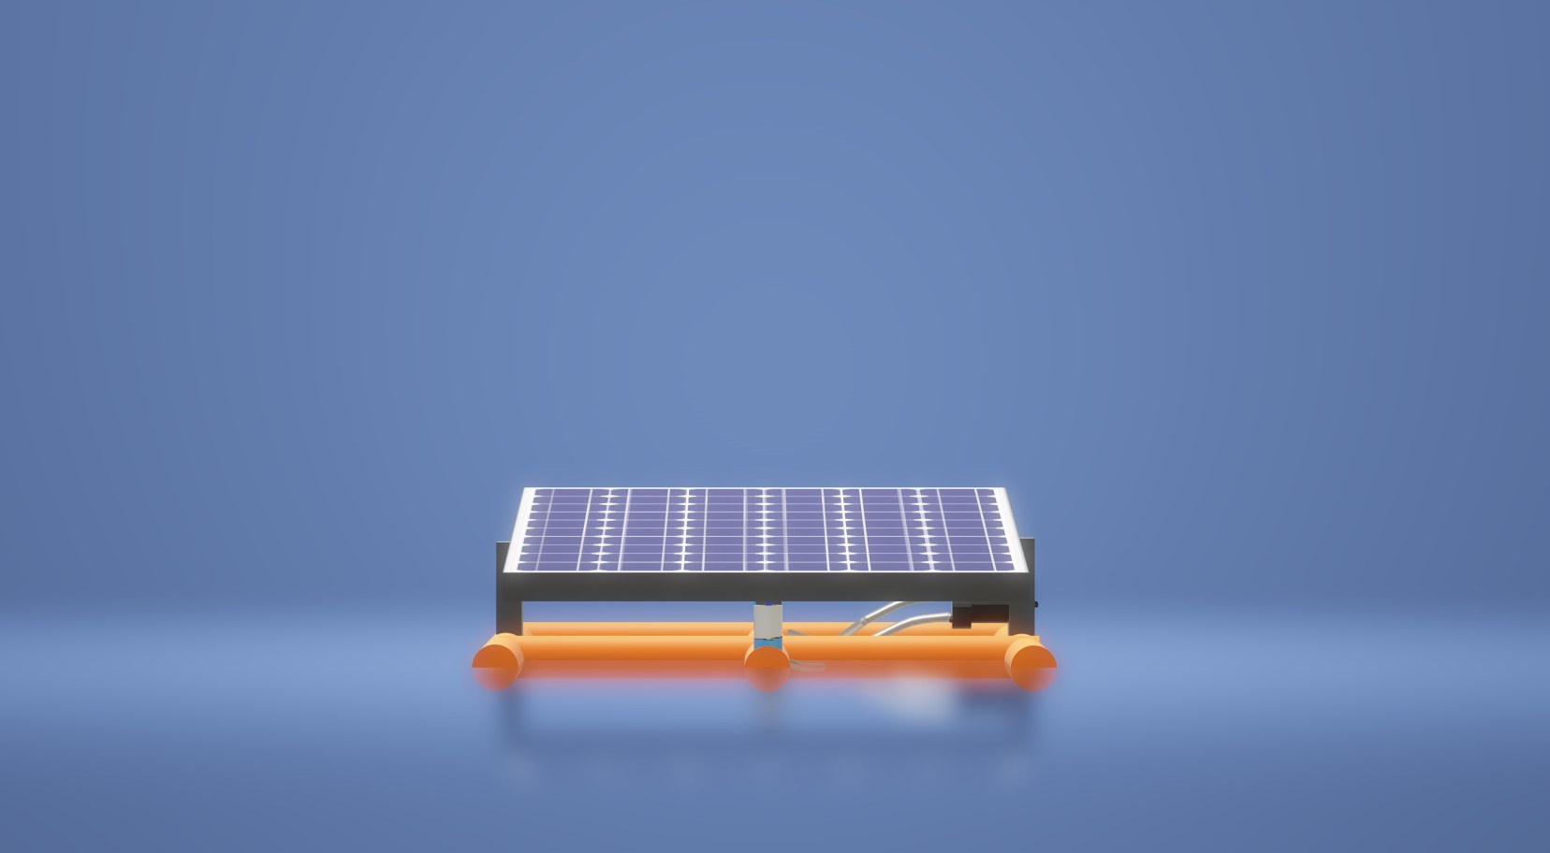
Side View
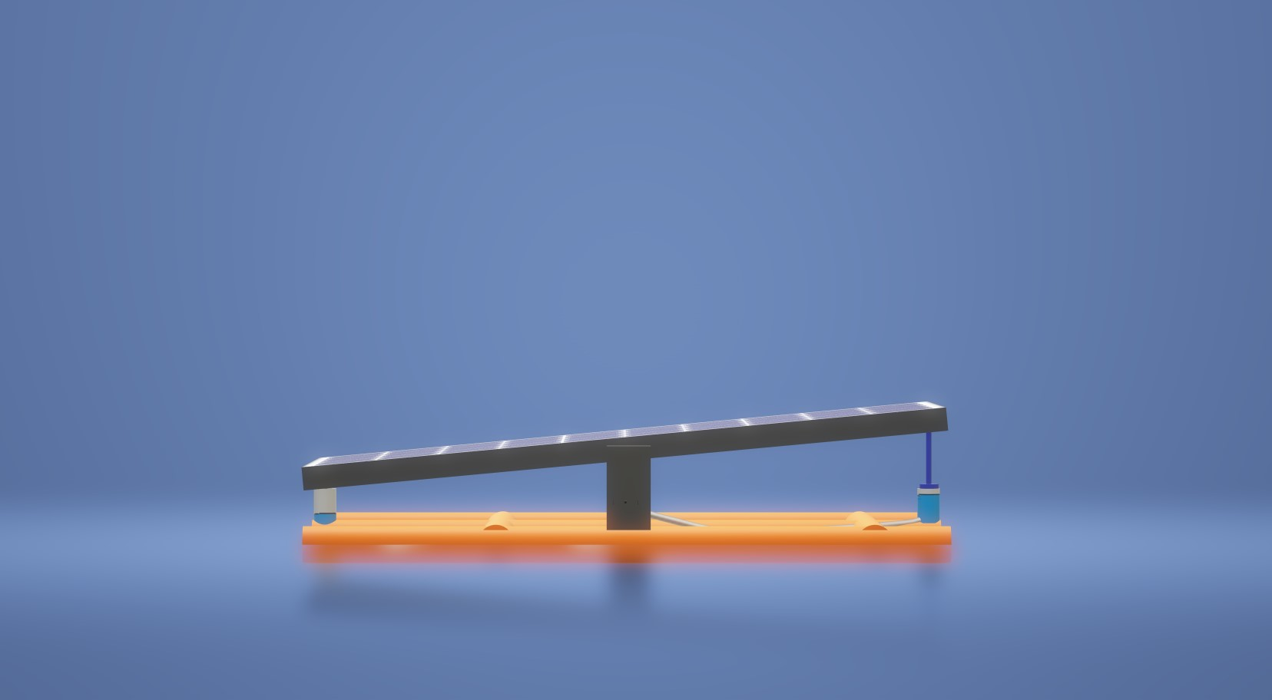

3D View
